# **Installing Python 2.7 and Pycharm IDE**

# **Installing Python** : -

**Step – 1:** - To Download Python visit python.org and choose python 2.7.14

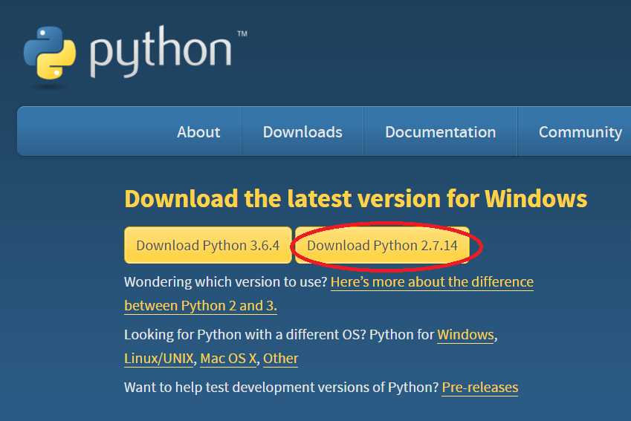

**Step – 2:** - Run python-2.7.14.msi file to Install Python

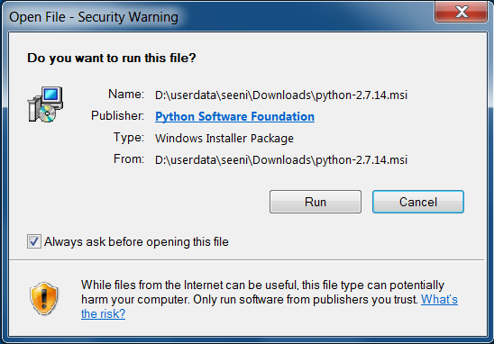

**Step – 3**: - Click Next to install Python for all users.

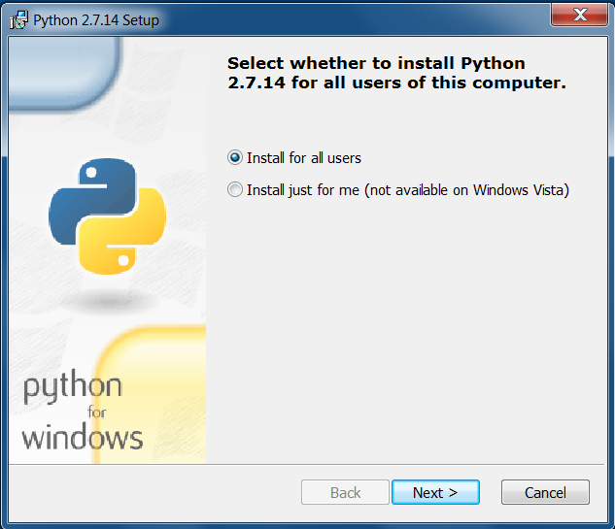

**Step – 4**: - Select the folder location to install.

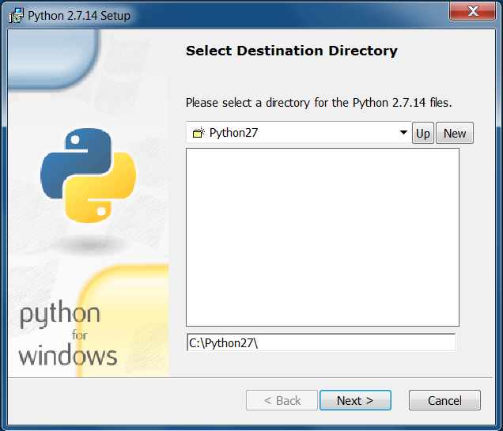

**Step – 5**: - Click next to install default features.

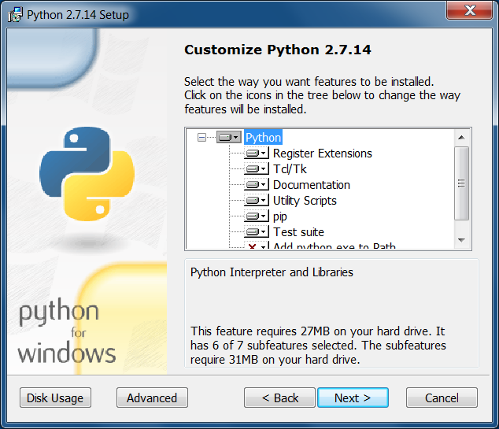

**Step – 6**: - Python Installation progress

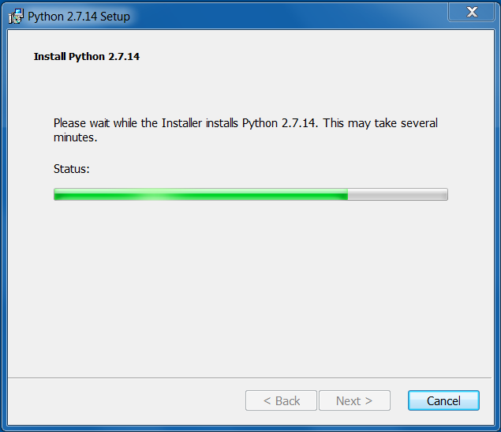

**Step – 7**: - Click Finish to complete python installation.

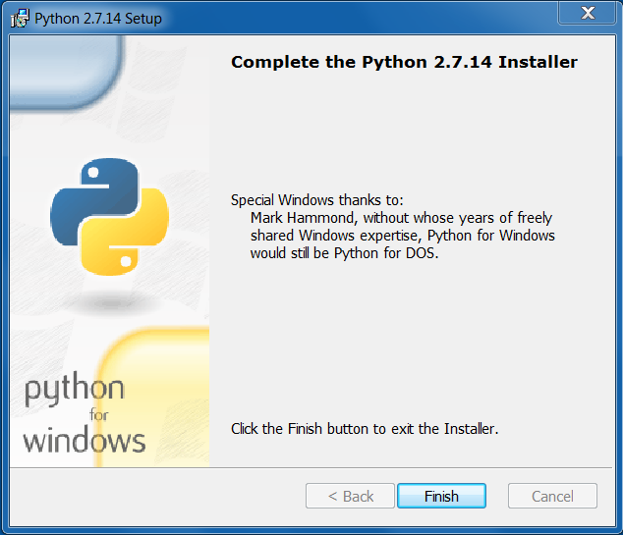

# **Installing Pycharm: -**

**Step – 1**: - To download Pycharm, visit <https://www.jetbrains.com/pycharm/download/#section=windows> and click download under the community edition

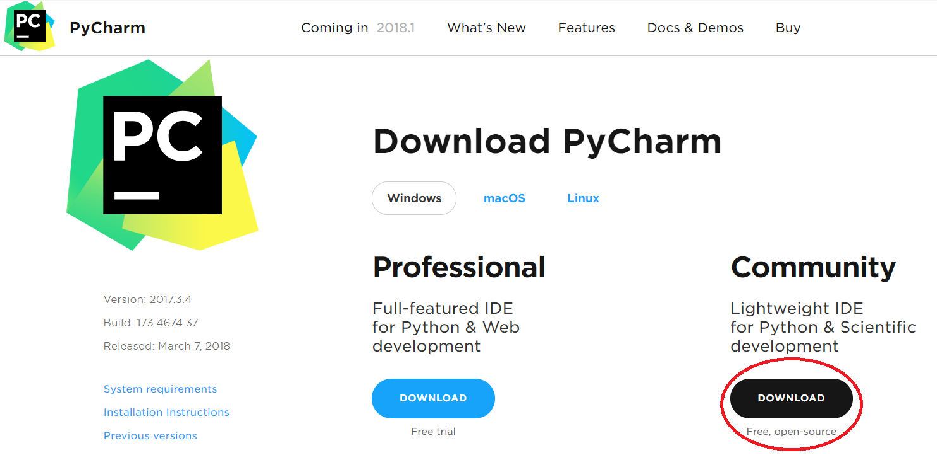

**Step – 2**: - Run pycharm-community-2017.3.4.exe file to Install Pycharm

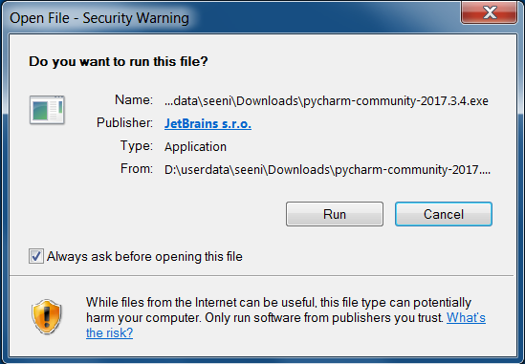

**Step – 3**: Click Next to continue installing

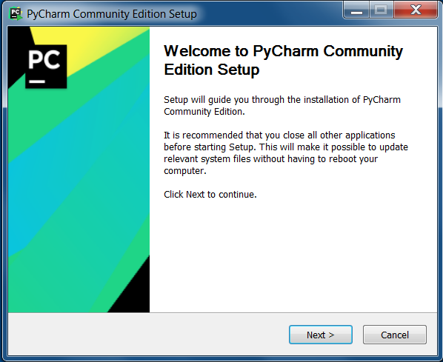

**Step – 4**: - Select the installation location if required and click next

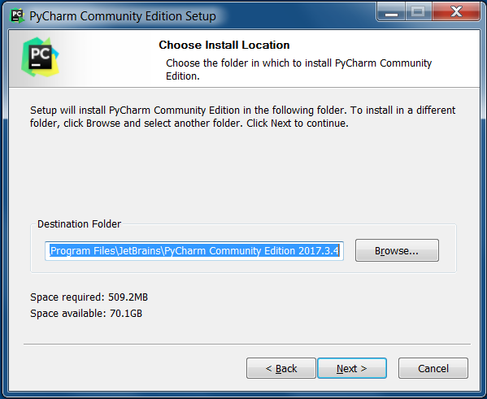

**Step – 5**: - select Desktop shortcut if needed and click next

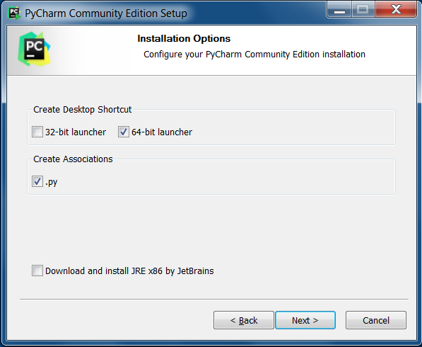

**Step – 6**: - Choose the start menu folder, let *‘JetBrains’* be the shortcut name and click Install.

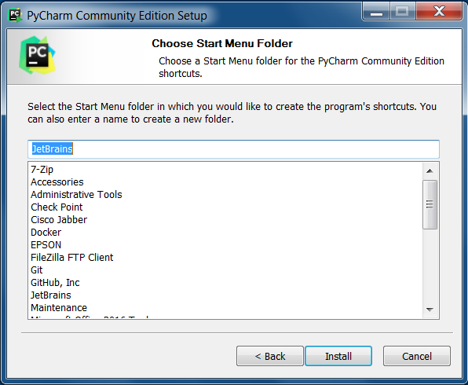

**Step – 7**: - Installation will begin

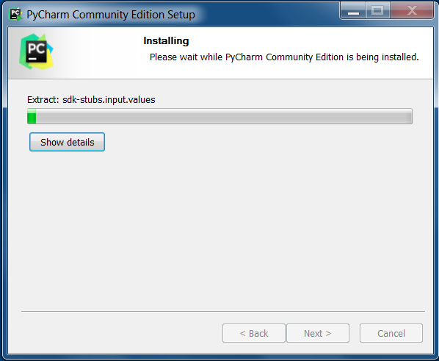

**Step – 8**: - Once the installation is complete, you will see the following window, click finish to complete the installation process.

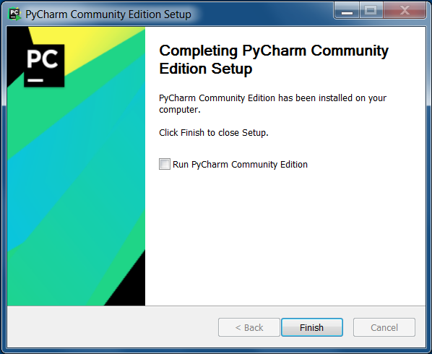

**Step – 9**: - When you run first time, you will see the below Prompt,

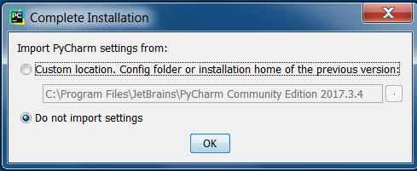

Select ‘Do not import settings’ option and click OK.

**Step – 1**0: - select the UI Theme and click ‘Skip Remaining and Set Defaults’.

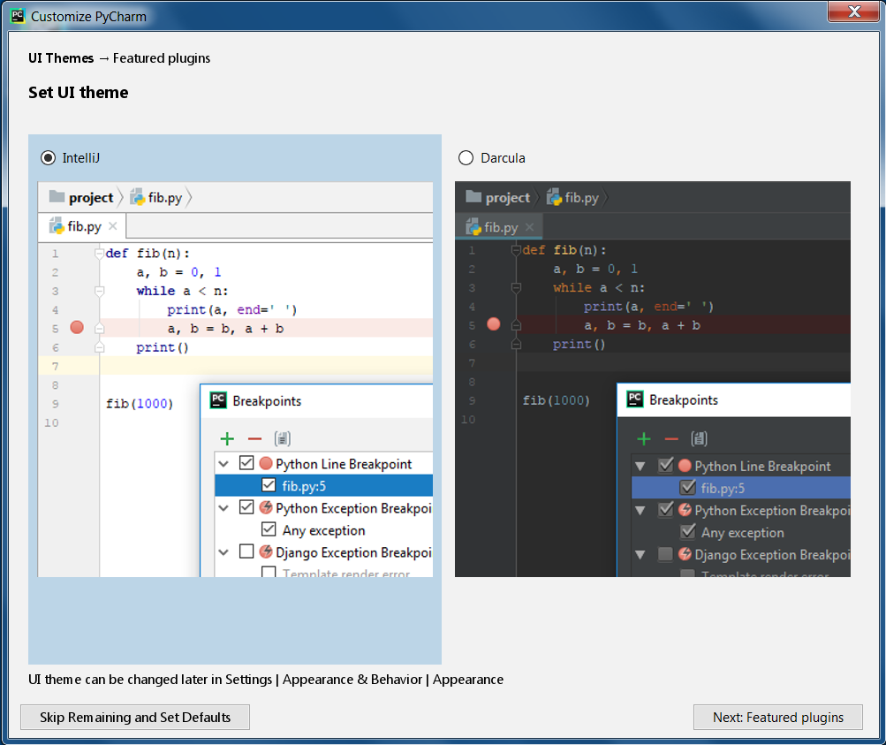

**Step – 11**: - After that you will see the following screen.

